**How to transform an IKEA FLUGBO floor lamp into a smart lamp using a Sonoff MINI R4**

**This guide shows an unofficial and unapproved way on how to transform an IKEA FLUGBO floor lamp into a smart lamp by installing inside a Sonoff MINI R4, so use it at your own risk. In no event shall the author of this guide be liable for any consequential, incidental or indirect damages whatsoever.**

**Caution: this floor lamp uses high voltage mains power (110V-220V) which is deadly, if you do not know what you are doing or you are not skilled enough call an electrician.**

**Circuit diagram**

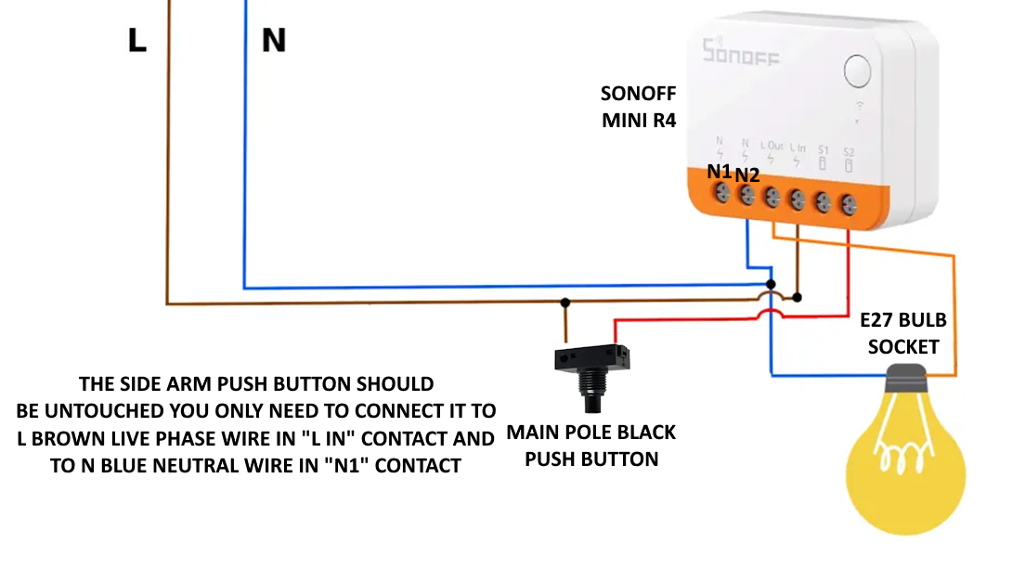

**Wires to be connected:**

* **N1: join and connect both blue neutral wires coming from the two push buttons (one on the side arm and one of the main pole)**
* **N2 (it is short circuited to N1): connect with a blue neutral wire to the E27 bulb socket**
* **L out: connect with a brown live phase wire to the other terminal of E27 bulb socket**
* **L in: join and connect the 2 brown wires coming from the two push buttons (one on the side arm and one of the main pole) with the other brown live phase wire coming from the power plug (so 3 wires)**
* **S1: unconnected (it is short circuited with L in contact, you can also plug any brown live phase wire from it here)**
* **S2: connect with a brown live phase wire to the other terminal of the main pole push button**

**What you need to buy:**

* **1 Sonoff MINI R4 smart switch (around 15€):** [**https://sonoff.tech/product/diy-smart-switches/minir4/**](https://sonoff.tech/product/diy-smart-switches/minir4/) 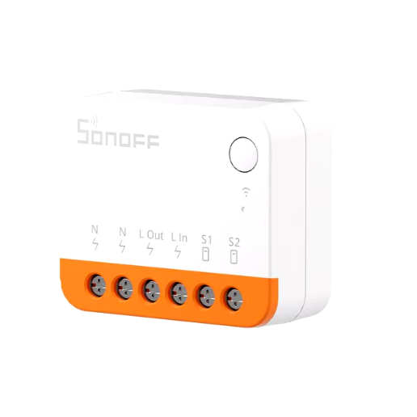
* **Electrical insulating tape (the wider the better, in Italy we have 25mm)** 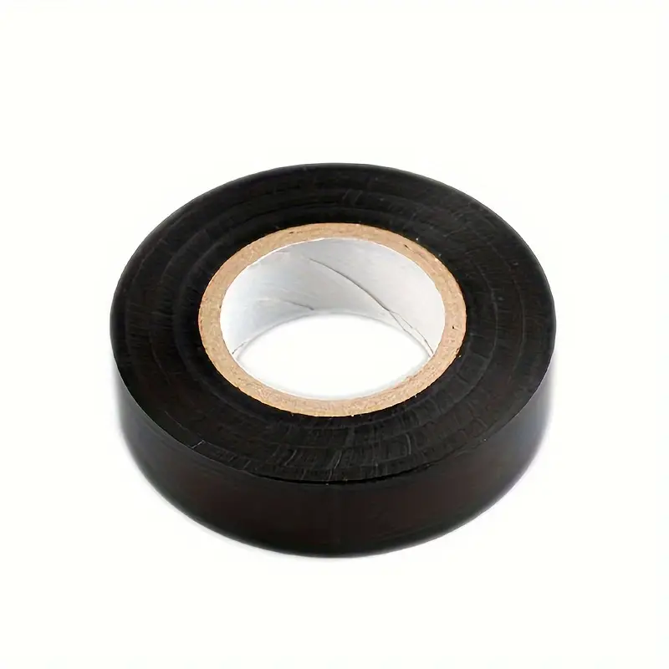
* **1m brown wire for lights (>= 1mm2 for 220V)**
* **1m blue wire for lights (>= 1mm2 for 220V)**
* **1 pair of electrically insulating gloves to wear during the work and in particular the initial testing**
* **An IKEA FLUGBO floor lamp  
  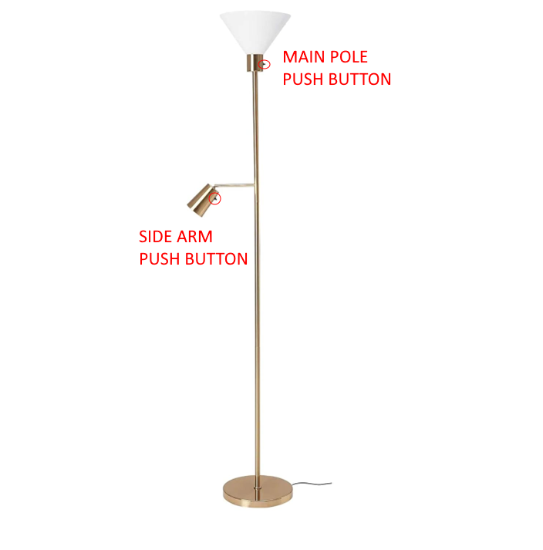**

**Instructions:**

1. **Disconnect the floor lamp from any power source.**
2. **Wear the electrical insulating gloves.**
3. Disassemble fully the top lampshade, the bulb socket, the black push button and the support plastic shell leaving just the 4 four wires from the main pole, 1 brown and 1 blue are respectively the live phase wire and neutral wire coming from power plug, in order to understand which one it is check both the brown wires with a tester; the other brown and blue wires are the live phase wire and neutral coming from the side push button.
4. For extra safety it is better to insulate all around the rounded inner metal shell with electrical insulating tape as in the picture below. The application in the picture is not the best one, yet it works, maybe you can also disassemble the rounded metal shell for a better application. The Sonoff MINI R4 has already a certified insulated flame-retardant enclosure which will be touching with its back the inner metal shell, this is just for extra safety.  
   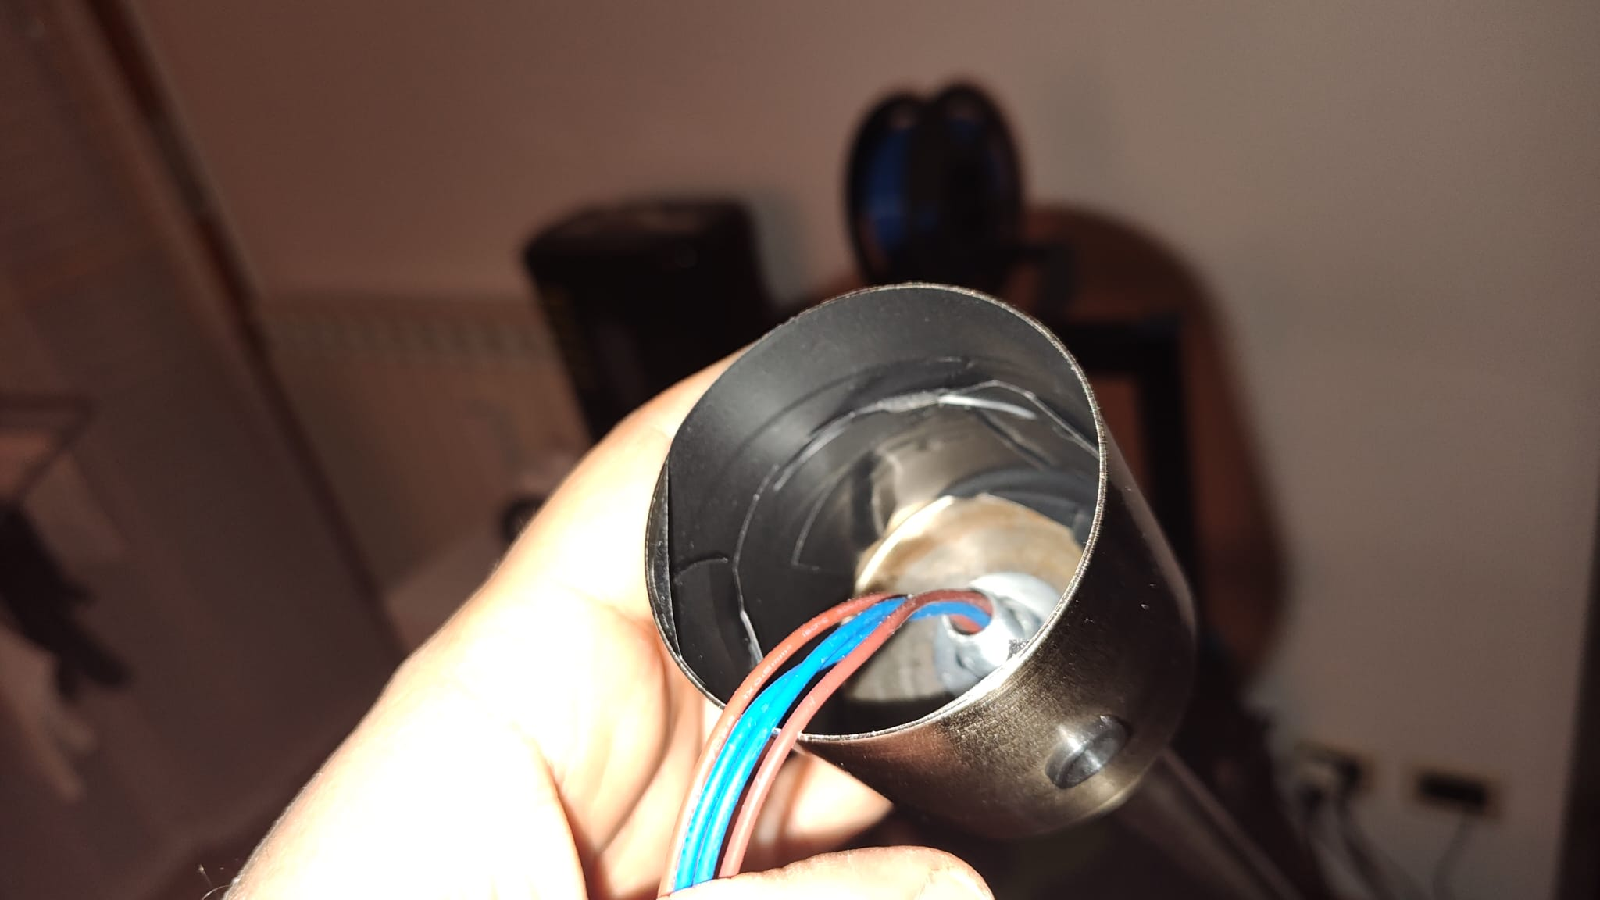
5. Carve a big hole on the plastic shell on which the bulb socket was screwed on the opposite side of the push button. How much big? Well, it has to allow the Sonoff MINI R4 to be installed diagonally, see the next picture (again the cutting like in the picture is not the best one, if you have a tool like a Dremel – I did not have one at the time I did this transformation - you can do a much better job). You have to try different times.  
   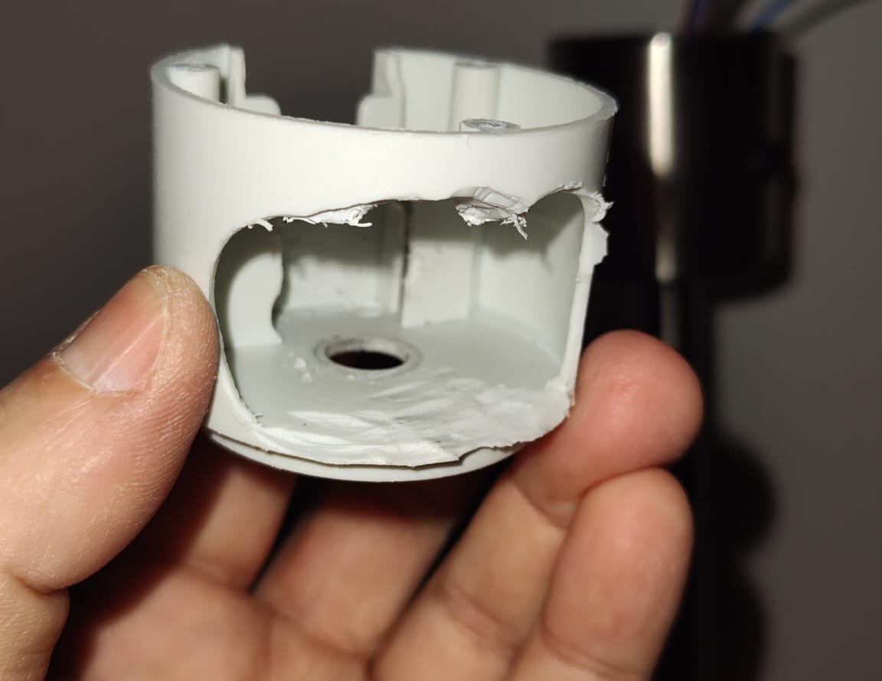

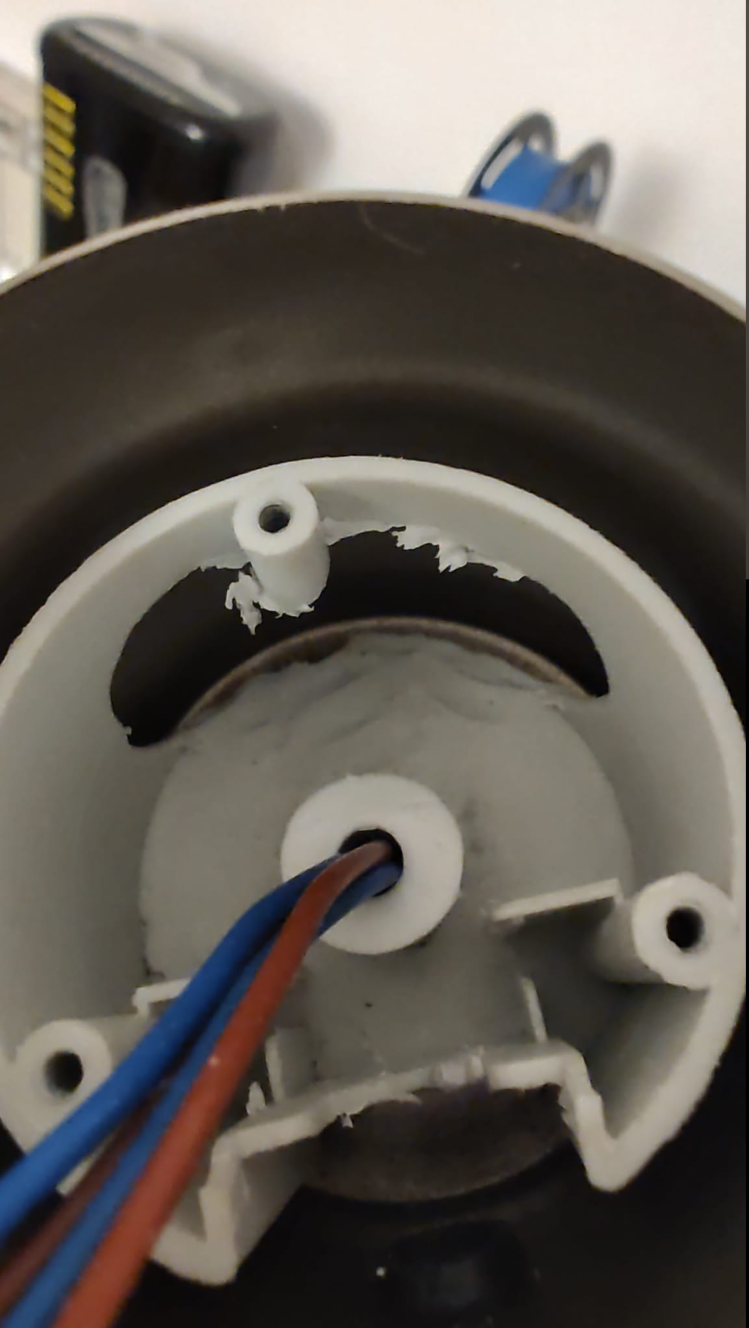 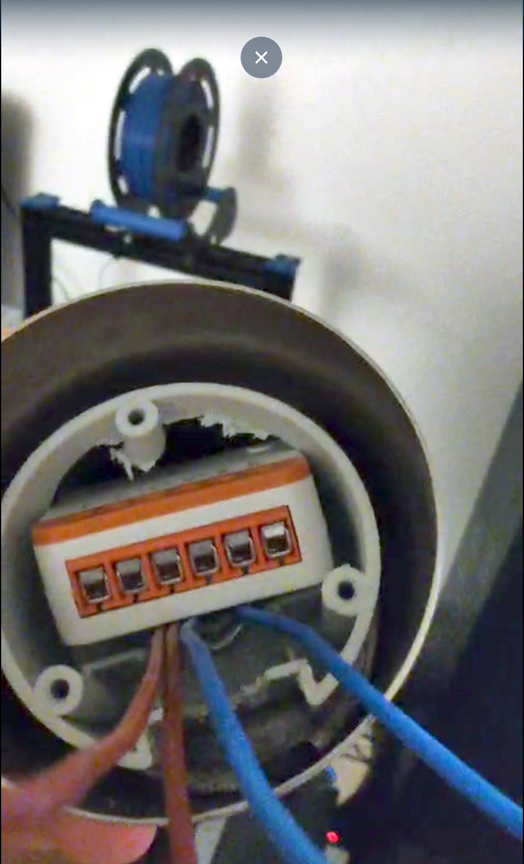

1. Take out the Sonoff and make the electrical connections as described in **Circuit Diagram** section. Test everything works without setting anything in place (caution do not let either the Sonoff or the push button contacts touch the metal of the floor lamp or you, as I said the lamp uses deadly mains power). To configure the Sonoff you have first to use the eWeLink app.

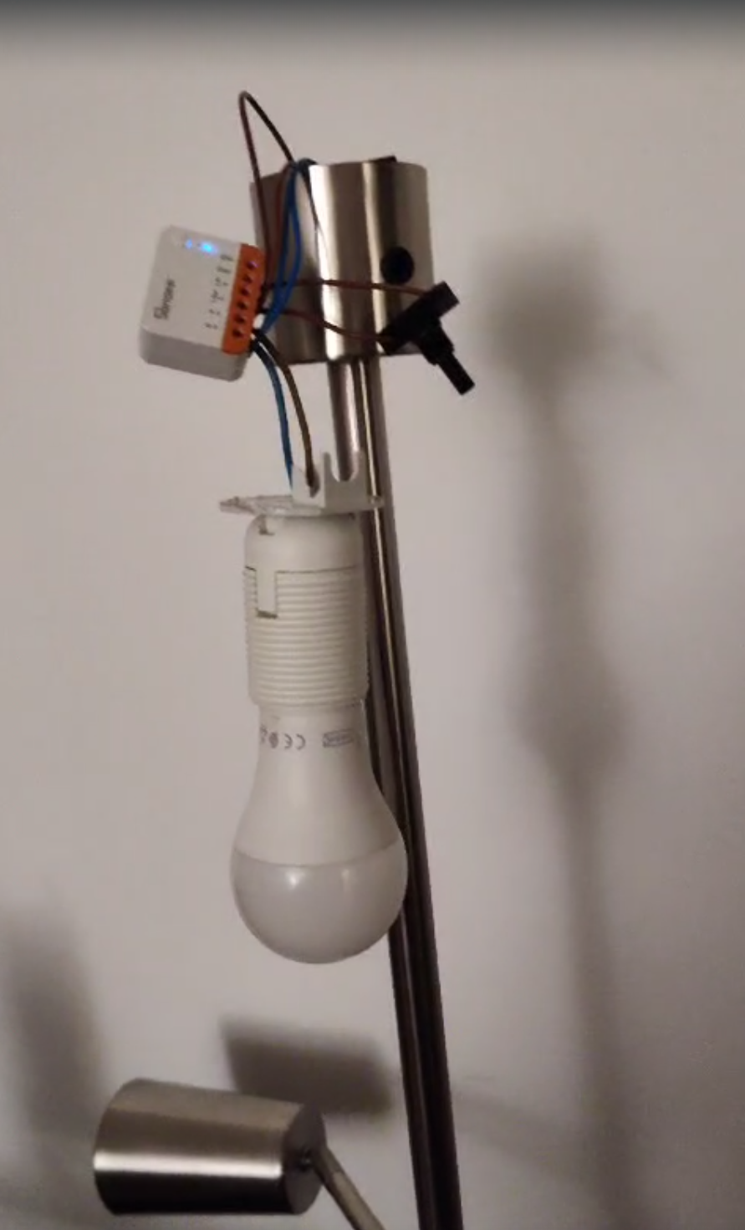

1. If everything works, **disconnect again any power source** and reassemble the Sonoff inside the plastic shell together with the black push button

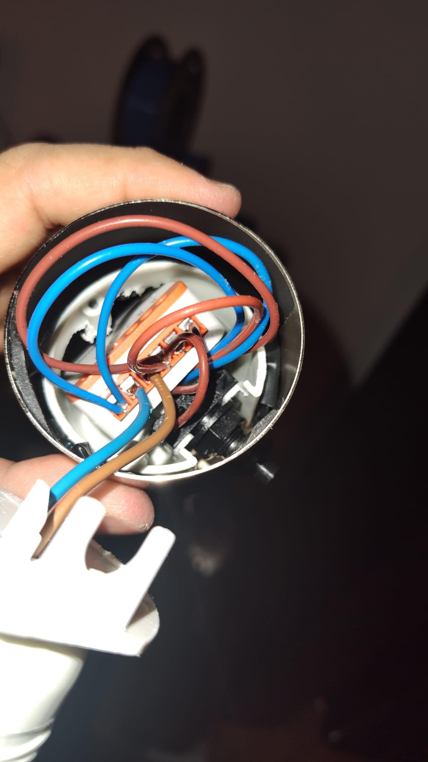

1. For extra safety you can apply a non-electrically conductive silicone sealant on Sonoff contacts, even though the Sonoff will be covered by the bulb socket support plastic.
2. Assemble everything else. Note that you have to cut a little bit the support plastic in order to be able to screw the bulb socket to it.

Final note: the button on Sonoff which allows you to reset its settings and change the wifi settings would be not reachable without reopening again the modified floor lamp. Luckily the eWeLink allows you to update directly in the app the wifi settings, so if you have to move the floor lamp to another house or you have to change the wifi SSID/password you can do easily from the app.